

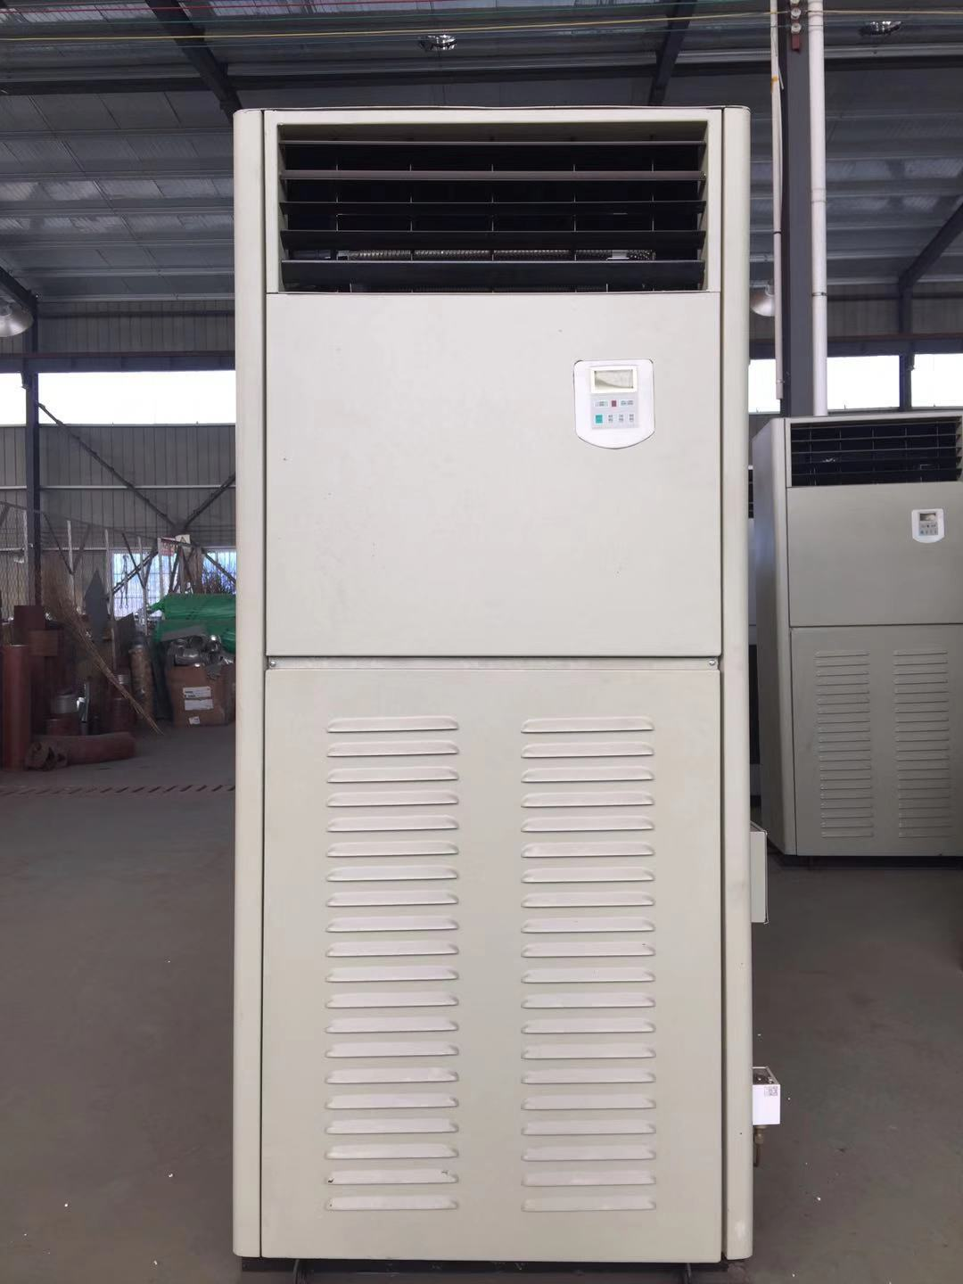
、

目 录
Contents
致用户………………………………………………………3
To Users …………………………………………………3
设备部件说明………………………………………………5
Instructions of the component ………………………5
机组操作说明………………………………………………9
Equipment operation ………………………………… 9
机组安全保护………………………………………………11
The safety protection of the unit …………………11
维护保养注意事项…………………………………………12
Maintenance matters need attention ………………12
常见故障原因及排除方法…………………………………13
Common failures and trouble shooting ……………13

致 用 户
To Users
欢迎你选用本厂制造的CLD系列船用立柜式空调装置。在使用前，请您仔细阅读本操作手册，以便掌握正确的使用方法，确保设备安全运行及延长使用寿命。
Welcome you to choose our manufacturing CLD series Marine air-conditioning equipment. Before using, please read the instructions carefully, to grasp the correct using method, ensure the equipment running safely and longer .
警告！
Cautions!
因用户使用不当造成的设备损坏，不在制造商的保修范围之内。
The improper use of equipment by the users is not in the range of manufacturers warranty
警告
Cautions!
由于空调设备的电气组件和压力设施有可能导致人身事故，所以切记：专业人员才可安装和维修空调设备。
非专业人员只可做一些维护工作，如清洗过滤网，其它的维修工作要经专业人员完成。
Because of the air conditioning equipment components and electric pressure facilities may cause accidents, so remember: Only professional personnel can do air-conditioning equipment installation and maintenance. Non-professionals can only do some maintenance work, such as clean strainer, other maintenance work to finish by professionals.
警告!
Cautions!
在维护和维修系统时，要切断电源。
使用正确的电压，否则对系统有害。动力线电源用刀闸或空气开关，接线要良好。不要有松动，否则有漏电、触电危险。每隔一个月，需检查并紧固所有电气连接端子。
In maintenance and repairing, remember to cut off power supply.
Using the correct voltage, otherwise it’s harmful to the system. disconnecting link or air switch should be used in power line power supply, and wiring should be good. Do not have loose, or else there is leakage, electric shock risk. Every month, you should check and tighten all the electrical terminals.
警告!
Cautions!
当供电电源的电压不正常时，系统将会出现异常，此时应立即关机，请专业电工人员检查供电系统，直到排除电源故障后，方可重新开机。
When the power supply voltage is abnormal, the system will appear abnormal , at this time , it should be immediately shut down, Please ask the professional electrician personnel to check the power supply system Till the power supply failure be excluded, restart your machine.
警告!
Cautions!
当装置运行出现故障时，应立即关机，并根据此操作手册查出故障所在，直到排除故障，方可开机。
When the equipment runs malfunction, it should be immediately shutdown, and find the faults according to the specifications, until the obstacle is conquered , restart your machine.
警告!
冬季或气温很低的地区，需排尽冷凝器中的余水，防止冻坏冷凝器。
Winter or when the temperature is too low, you should drain off the water of the condenser to prevent condenser being frozen.

设备部件说明：
Instructions of the component
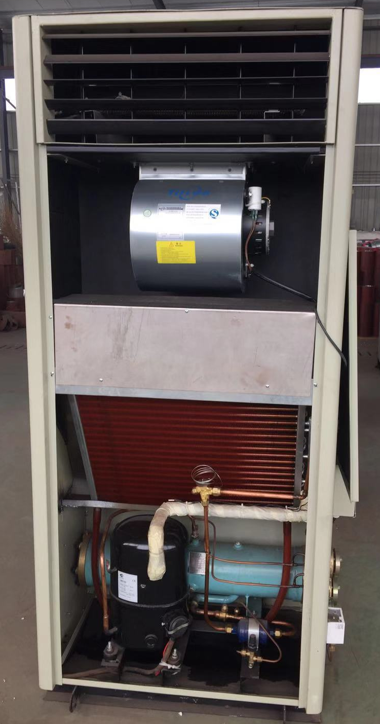
1

2

3

4
5
6

7
8
9
10

空调出风口
Exhaust outlets of Air-condition
空调风机
air-conditioning fan
空调电气控制箱
Air-conditioning electric control box
蒸发器
Evaporator
膨胀阀
Expansion valve
制冷压缩机
Refrigeration compressor
压缩机吸气口
Compressor suction port
船用冷凝器
Marine condenser
压缩机排气口
Compressor vent
制冷剂充注截止阀
Refrigerant filling stop valve
仅供机组出厂前充注制冷剂使用，机组正常运行时，请确保该截止阀关闭，且末端已用闷头封闭.
Only offer for the unit before filling refrigerants used during normal operation, the unit, please ensure that the stop valve is closed, and ends with cocks being closed already.

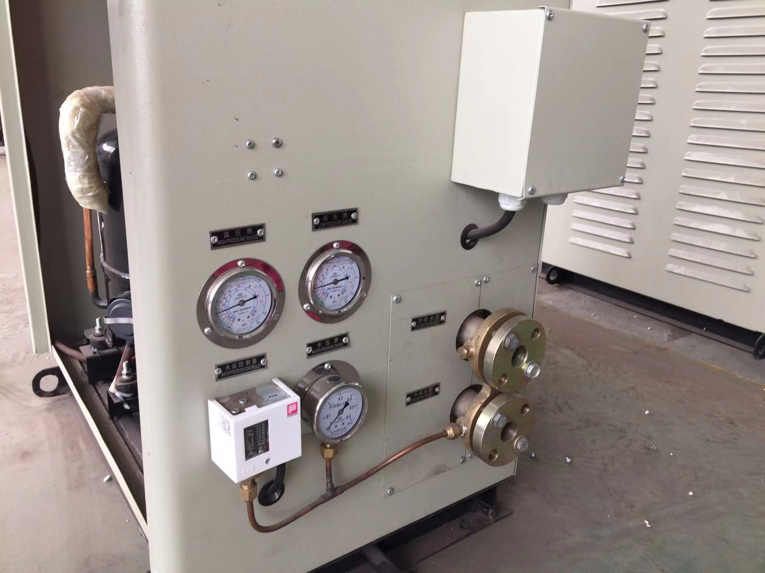
11
12
13
14
15
16
17

高压表
High pressure gauge
低压表
Low pressure gauge
机组外部电源接入盒
Power access box outside the unit
水压控制器
Hydraulic controller
水压表
water pressure gauge
冷凝器出水口
water outlet of the condenser
冷凝器进水口
water inlet of the condenser

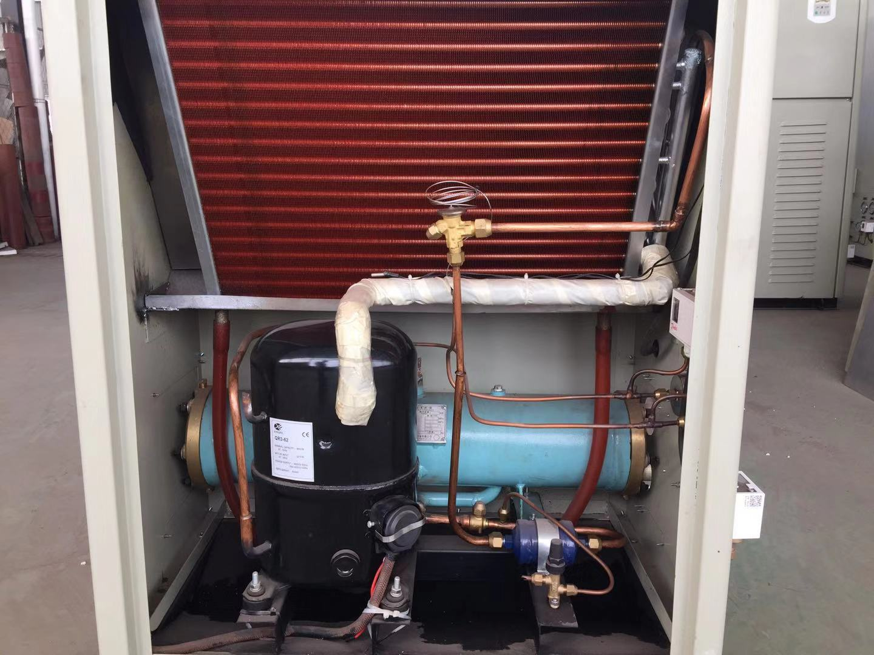
19

18

制冷剂干燥过滤器
Refrigerants filter drier
高低压控制器
High-voltage controller

机组操作说明
Equipment operation
用户提供电源AC380V 50Hz 3φ
Users provide power supply: AC380V 50Hz 3φ
若需制冷先提供冷却水，保证冷却水量且必须保持水压0.07~0.1Mpa
If refrigeration is required, cooling water is provided first, the cooling water is guaranteed and the water pressure 0.07~0.1Mpa must be maintained.
1：送合空气开关，电脑板得电，显示室内温度，按 按钮，风机运行；
开/关
1：Close air switch, computers boards have electricity and show indoor temperature, press bottom, fan starts to operate;
open/close
2：按 按钮，选择自动、制冷、通风或加热功能；空调有三档风速调节，若需调节风速按 按钮，建议制冷模式下选择高档风速，加热选择低档风速；
模 式
风 速
2：Press bottom，Choose automatic cooling, ventilation, heating function; Air conditioning has three kinds of speed adjustment，If you need to adjust speed, press bottom，we advise you to choose high-grade winds in refrigeration mode, and choose low-grade winds in heating mode;
Mode
wind speed
3： 选择自动，通过 按钮设定温度，电脑板通过与房间温度比较后，自动进行制冷或加热运行。
∇ 温度 Δ
3：Choose automatic, Set temperature through bottom，the computer board automatically sets temperature refrigeration or heating through comparing with room;
∇ temperature Δ
4： 选择加热，通过 按钮设定温度，送风机运行，机组加热，在制热过程中，电脑自动控制加热功率，选择“制热”工作方式后，设定温度值要高于当时房间的温度，如果设定值低于当时房间的温度，空调器不工作，当关闭加热状态下的机组后风机自动延时3分钟关闭，以排除机组内余热防止灼坏机组内部部件，至风机自动停止后方可切断机组电源；
∇ 温度 Δ

4：Choose heating, Set temperature through bottom，The air supply fan works ,the unit is in heating process, when heating, computer automatically control heating power, choose "heating", the setting temperature is higher than temperature in the room, if the setting temperature is lower than the temperature in the room, the air conditioner will not work, when close the unit in heating condition , fan will automatically delay to 3 minutes , to prevent burning generator units within the internal components, you can't cut off power supply until fan automatically stops;
∇ temperature Δ
5： 选择制冷前，先提供冷却水，保证冷却水量建立正常的水压（0.07~0.1Mpa），通过 按钮设定温度，风机、压缩机运行（注：压缩机再起动具有3分钟延时保护），机组制冷；当空调机温度设定好后，请不要任意改变设定温度，以防压缩机不能自停而损伤压缩机；
∇ 温度 Δ
5：Before selecting refrigeration, supply cooling water to ensure normal water pressure (0.07~0.1Mpa) of cooling water.，Set temperature through bottom，fan, compressor operates（Note: compressor has 3 minutes protection delay when restart），Unit refrigeration, When the air conditioning temperature setting, please don't change temperature freely, in case any change can’t stop the compressor or damage the compressor ;
∇temperature Δ
6： 压缩机具有高（排气）低（吸气）压、过载保护，送风机具有过载保护，当其中之一发生故障时，自动停车，至故障排除，高压保护需手动复位，其他保护自动复位。
6：Compressor has high (exhaust) and low(suction) Pressure differential, overload, protection, ventilator has overload protection, when one of them malfunction, it will automatically park, and till troubleshooting, high-pressure protection need manually reset, and other automatically reset.
注：空调机不用或维修的日子里，请切断空调机的电源。
Note: When the air conditioner is in maintenance days or do not need to work, please cut off the power supply of air conditioning.

机组的安全保护
The safety protection of the unit
1：制冷压缩机高、低压保护，调定值根据制冷剂的不同而不尽相同；
1: Refrigeration compressor has high and low voltage protection, the setting value will vary according to different refrigerants ;
2：制冷压缩机过载保护，制冷机内自设；
2: Refrigeration compressor overload protection is set by refrigerator automatically;
3： 冷凝器易熔塞超热保护，当压缩机排至冷凝器汽体温度超过安全值时，易熔塞熔动作；
3: The condenser fusible plugs super thermal protection, when compressors discharge to the condenser steam temperature is over , it is fusible plugs welding action;
4：电加热器超温保护，当电加热表面温度高于安全值时，电加热器电源自动切断；
4: When electric heater is in overheat protection, electricity heating surface temperature is higher than that of safe value, electric heater will automatically cut off power supply;
5：风机与制冷压缩机电加热器联锁保护，不开风机，制冷和加热均无法进行；
5: fan and refrigeration compression electrical heater interlock protection, don't open fan , both cooling and heating are unattainable;
6：冷凝器缺水保护，没有冷却水或水压力不足，制冷压缩机无法启动；
6: condenser lack water protection, no water or water lackage, refrigeration compressor cannot startup;
7：控制线路和电器超电流保护。
7: The control circuit and electrical over current protection
维护保养注意事项
Maintenance matters need attention
请仔细阅读以下内容，以便有效延长机组使用寿命
Please read the following content, in order to prolong the service life
1： 选择“制冷”工作方式时，为了延长压缩机使用寿命和节约用电，推荐您将空调机温度控制器的设定温度设定在24~30°C。选择“制热”工作方式后，温度设定不高于24°C；
1:Choose the "cooling" mode,we recommend you to set the temperature of air conditioning temperature controller in 24-30 ° C to prolong life of compressor and conserve electricity. Choose the "heating" mode, the temperature setting should not be above 24 ° C ;
2：一个季度清洗一次空气过滤网和蒸发器翅片上的灰尘；
2:You should clean the dust in the air filter and evaporator fin once a quarter;
3： 每次运行查看高低压压力表并记录压力值和制冷效果；
3: Check the high and low pressure gauges and and refrigeration effect every running time ;
4：保护空调机面板和壳体的清洁，防止锈蚀；
4:Keep the air conditioning panel and shell clean to prevent corrosion;
5：空调机在运转时，发现异响或有焦味时要立即停机检查原因，排除故障后再运转；
5:When the air conditioner is in operation, if you hear special sound or scorchedflavor, you should immediately stop to check out the reason , and restart after the trouble-shooting;

6： 三个月以上时间不使用冷凝机组时，应关闭冷却水进水截止阀，并将冷凝机组中的余水放净，防止冬季气温过低造成冷凝器损坏；
6:Three months time without the use of condensing units, close cooling water to cut-off valve, and drain off the water of the condensing units,to prevent the damage of the condenser coused by the low temperature of winter;
7：每年一次对空调机电器和电机设备测量一次绝缘电阻；
7: Measure the air conditioner and electrical motor equipment once a year for insulation resistance ;
8：空调机使用三年后进行一次大检查，需拆检制冷系统时，必须由专业人员进行。
8:Three years after using, a big examination overhauling refrigeration system must be done by professionals.
注：定期对机组进行维护保养（便于机组正常运行，延长使用寿命），维护保养工作必须在断开主电源后才能进行，不允许带电操作。
Note: Regular maintenance (easy for units to normal operates , and prolong the using time ),maintenance work must be done after the disconnected of the main power, forbid power operation.

常见故障原因及排除方法
Common failures and trouble shooting
故障 Fault | 原因 Reasons | 排除 Elimination
压缩机不运转  （电气原因）  Compressor doesn't work(Electrical reasons） | 电源没电、保险丝熔断、三相电缺相、压力继电器动作  No electricity supply, the fuse blows, three-phase power lack of phase, pressure relay | 检查电源、换保险丝、排除缺相、修复压力继电器  Check power, replace the fuse, eliminate phase, repair pressure relay
压缩机开、停频繁  Compressor opens or closes frequently | 制冷系统压力不正常（压力太低）、压力继电器调整不当  Refrigeration system pressure is not normal (low pressure), pressure relay improper adjustment | 检查是否漏制冷剂、重新调整设定值  Check whether leakage refrigerants, readjust value
压缩机不停机  Compressor non-stop | 制冷剂不足或泄漏、温度设定不当、压力继电器故障  Refrigerants insufficiency or leakage, temperature, pressure relay setting fault | 检漏，补充制冷剂、重新设定温度、修复压力继电器  Leakage, supplementary refrigerants, temperature, pressure relay
启动后停机  Start up and then shutdown | 冷却水阀，出液阀等未打开、温度控制器调整不当  Cooling water valve, the valve opens, temperature controller such improper adjustment | 检查并使阀开启、重新设定温度  Check and make valve opens and reset temperature
压缩机电机过热  Compressor motor overheating | 电压低造成电流大、冷冻油不足，润滑不良、超载运转、制冷剂内混有空气、电机绕组绝缘破坏  Current, voltage caused by inadequate, bad lubrication oil frozen, overload, refrigerant in air, the motor winding is mixed insulation failure | 根据相关情况处理  Deal with it according to the related information processing
排气温度过高  The exhaust temperature is too high | 吸气过热度大冷却水量不足或出水阀开启过小  Suction superheat large cooling water insufficient or outlet valve opening too small | 增加过液量和调整膨胀阀的开启度，调节冷却水  Increase the amount of excess liquid and adjust the opening degree of expansion valve, adjust the cooling water
吸气温度过高  Inspiratory temperature was too high | 制冷剂不足或泄漏、膨胀阀开度过小  Insufficient or refrigerants expansion valve leakage, spend little | 检漏，补足制冷剂、调整膨胀阀开度  Leakage, complemental refrigerants, adjustment of the expansion valve
吸气压力过高  Inspiratory pressure is too high | 制冷剂过量、热负荷过大、膨胀阀开度不当、感温包安装不牢  Excessive refrigerant, excessive heat load, improper opening of expansion valve, inadequate installation of temperature sensitive package | 放出多余制冷剂、调整负荷、调整膨胀阀开度、重新包扎感温包  Release the excess refrigerant, adjust the load, adjust the opening of the expansion valve, re-wrap the temperature package
吸气压力过低  Inspiratory pressure is too low | 有冰塞、制冷剂不足、蒸发器脏堵、膨胀阀开度太小、膨胀阀有冰塞，脏堵、感温包泄漏、供液管上的阀开度不够、液管堵塞、空气滤网灰尘太多  There is ice jam, refrigerant, evaporator, dirty expansion valve is too small, expansion valves have ice jam, dirty, temperature, fluid leakage of valve, tube jam, air filter dust too much | 去除系统中的水份、清除蒸发器的脏堵、调整膨胀阀开度、清除膨胀阀脏堵，冰塞、更换膨胀阀、调整阀的开度、清除液管堵塞、清洗空气滤网  The moisture removal system, evaporator, adjust the dirty expansion valve, remove expansion valves, dirty ice, replace expansion valves, adjust valve opening and remove liquid and clean air filter tube jam
排气压力过低  Exhaust pressure is too low | 冷却水量过大、制冷剂不足或泄漏  Cooling water shortage or excessive, refrigerant leakage | 减小冷却水量、检漏，补充制冷剂  Decreases cooling water leakage, and added refrigerants

本操作手册仅适用于江苏启星空调系列设备
This manual is only applicable to the Marine air conditioning unit series of Jiangsu Qixing AHU Co. Ltd.
本手册最终解释权及修改权归泰兴市启娴船用机械有限公司所有
The manual interpretation and modification to Taixing Qixian Marine Machinery Co.,Ltd.

泰兴市启娴船用机械有限公司
Taixing QiXian Marine Machinery Co. Ltd.

Tel：0523-87606083
Fax：0523-87606083
7×24客服热线(Customer service hotline)：（0）13852673821
http://www.txqxjx.com/
Email:taixingqixing@163.com

