

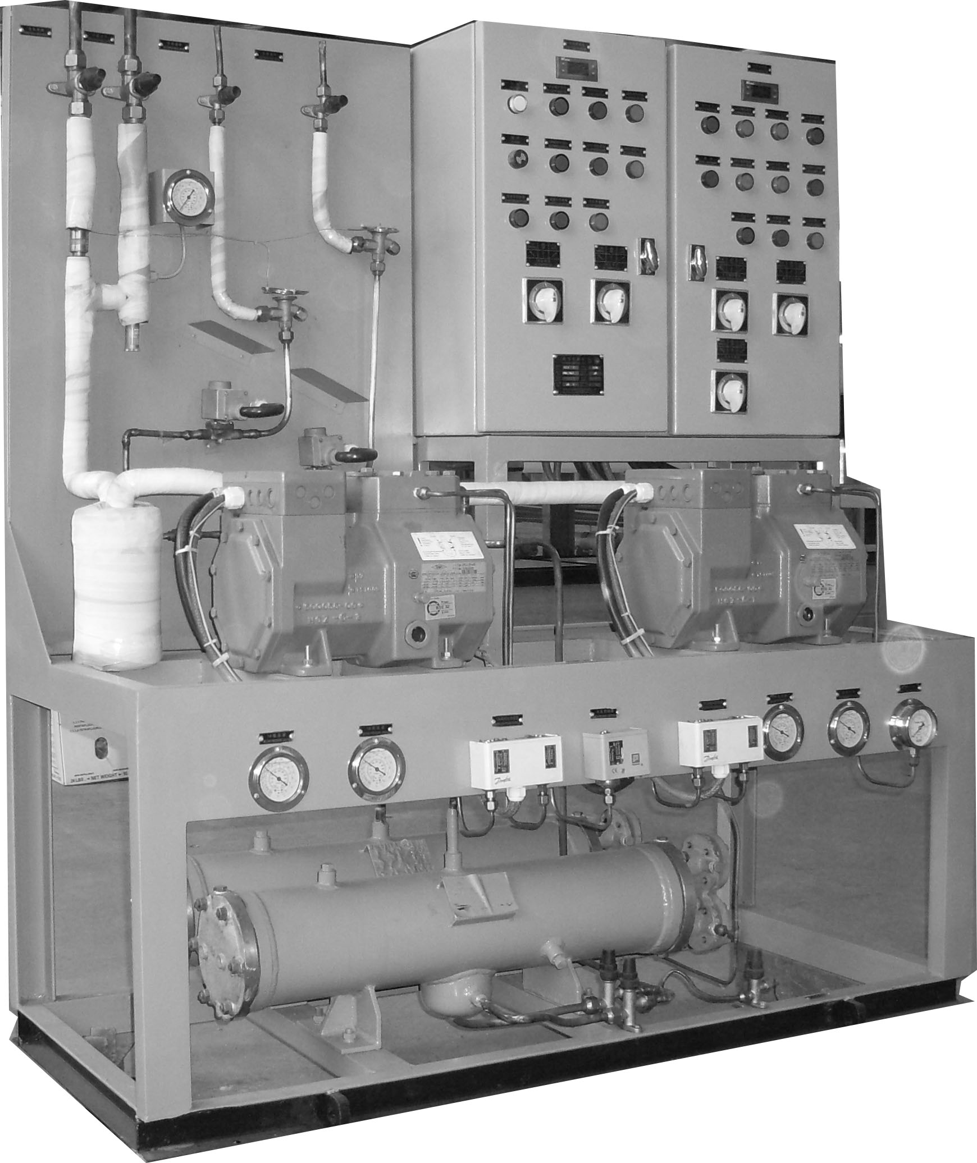

目 录

致用户………………………………………………………3
设备部件说明………………………………………………4
设备操作说明………………………………………………7
其他说明事项………………………………………………9
制冷设备常见故障排除……………………………………11
致 用 户
欢迎你选用本厂制造的CLC系列船用组装式冷藏装置。在使用前，请您仔细阅读本使用说明书，以便掌握正确的使用方法，确保设备安全运行及延长使用寿命。
警告：
因用户使用不当造成的设备损坏，不在制造商的保修范围之内。
警告!
由于设备的电气组件和压力设施有可能导致人身事故，所以切记：专业人员才可安装和维修空调设备。
非专业人员只可做一些维护工作，如清洗过滤网，其它的维修工作要经专业人员完成。
警告!
在维护和维修系统时，要切断电源
使用正确的电压，否则对系统有害。动力线电源用刀闸或空气开关，接线要良好。不要有松动，否则有漏电、触电危险。每隔一个月，需检查并紧固所有电气连接端子。
警告!
当供电电源的电压不正常时，系统将会出现异常，此时应立即关机，请专业电工人员检查供电系统，直到排除电源故障后，方可重新开机。
警告!
当装置运行出现故障时，应立即关机，并根据此说明书查出故障所在，直到排除故障，方可开机。
警告!
冬季或气温很低的地区，需排尽冷凝器中的余水，防止冻坏冷凝器。
设备部件说明
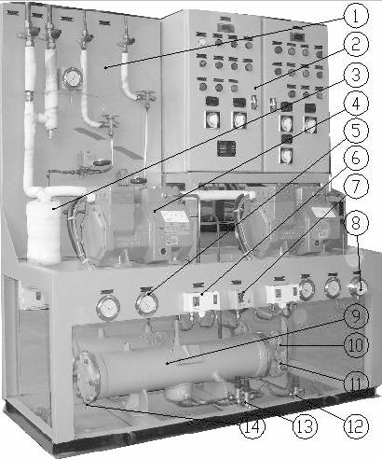

机组制冷阀板
机组电控箱
汽液分离器
制冷压缩机
高低压表
高低压控制器
水压控制器
水压表
冷凝器
严寒地区或环境温度低于5℃时，用户需自行排尽冷凝器内剩余海水，否则将会损坏冷凝器，且因此原因引起的所有损失，不在制造商保修范围之内；
冷凝器冷却水出水口
冷凝器冷却水进水口
制冷剂充注截止阀
仅供机组出厂前充注制冷剂使用，机组正常运行时，请确保该截止阀关闭，且末端已用闷头封闭；
制冷剂供液截止阀
仅供机组在出厂时集中系统内的制冷剂使用，该操作需由专业人员进行；
冷凝器放水旋塞

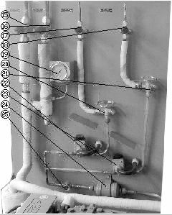

自高温（蔬菜）库回汽阀自低温（鱼肉）库回汽阀
至高温库供液阀至低温库供液阀蒸发压力表
高温库膨胀阀低温库膨胀阀
高温库供液电磁阀低温库供液电磁阀
制冷剂干燥过滤器
视液镜

设备操作说明
用户提供主电源AC380V 50Hz 3φ
本装置由制冷压缩机、船用冷凝器、干燥过滤器、阀件、控制元件及电控箱等组成，并配套供应所需的冷风机
1. 先提供冷却水， 起动冷却海水泵，建立正常的水压（低于0.07Mpa水压控制器为保护压缩机触点打开，达到0.1Mpa控制器触点闭合可以下一步操作）；冷却水压力达不到水压继电器调定值上限时，电路不通，压缩机不能启动，水压达到上限时，压缩机才能启动，若水压下降到水压继电器下限时，水压继电器触头断开，压缩机停机；
2. 起动冷风机，机组控制箱上的高温（蔬菜）、低温（鱼肉）库供液转换开关，建议二者调至自动档位，调至手动档位压缩机不受温度控制器保护；
3. 压缩机开停可自动控制或手动控制
手动控制：
按压缩机起动按钮，压缩机运行，指示灯亮；
按压缩机停止按钮，压缩机停止运行；
4. 每个冷库都各自有一只温度调节器，库温由相应的温度调节器控制，即当库温下降到温度调节器的设定值下限时，温度调节器动作，相应的供液电磁阀关闭，相应的冷风机停机；当库温上升到温度调节器的设定值上限时，温度调节器节器动作，相应的供液电磁阀开启，相应的冷风机启动。
低压：
当压缩机吸气压力下降到低压继电器设定值时（0.03Mpa）压缩机停机，超过上限（0.4Mpa）时，压缩机启动。
高压：
当排气压超过2.0Mpa时，高压继电器动作，压缩机停机，并报警， 手动复位；
▲低温（鱼肉）冷风机自动融霜由时间继电器控制；亦可手动控制。
其他说明事项
1.机组试运行时先用手动控制，待正常运行后，转换到自动控制位置。
2.运转中的检查
a.检查压缩机视油镜的油位，是否符合规定要求，油面稍有波动，但无泡沫形成；
b.检查系统中各压力表是否均在规定的使用范围内；
c.检查各连接部位是否有泄漏和渗透现象，如发生上述现象应及时停机处理，处理时严禁使用明火；
d.检查电磁阀的工作情况；
e.检查热力膨胀阀的工作情况；
f.若运转中有异常现象，则应先停机，切断电源，再检查，找出原因，然后采取相应的办法处理。
g. 压缩机各部位发热正常，无剧热处；
h. 压缩机运转平稳，无剧烈振动；
3.低压停车是制冷系统自动控制的正常现象；
4.高压停车并报警是制冷系统出现故障，应切断电源后检查故障原因，并在排除故障后，手动复位；
5.如只需短时间停机，切断电源即可；
6.运转中若发生异常，除停机切断电源外，还得顺序关闭供液截止阀，压缩机吸排气阀，然后进行检查与维修；
7.压缩机的吸排气阀关闭后，不得再启动压缩机；
8.若制冷装置需长时间停用时，则应将制冷剂收入贮液器中，方法如下：
a.关闭贮液器的供液阀；
b.待压缩机的吸气压力降至接近“0”时，切断电源，使压缩机停机，停机后如压缩机吸气压力回升较快，则必须重新启动压缩机，直至吸气压力接近“0”时比较平稳；
c.停机后，再关闭压缩机吸排气阀，关闭后，不得再启动压缩机。
9. 为使机组能正常运行及延长使用寿命，应定期对机组进行维护保养
本厂有权对产品进行技术修改，恕不另行通知。
制冷设备常见故障及排除方法
故障情况 | 发生原因 | 排除方法
压缩机不能启动或启动后即自动停车 | 1.源插头接触不良  2.保险丝断  3.缺相  4.电机烧坏  5.吸排气截止阀未打开，致使高低压控制器调整不当  6.系统的低压控制管路缺乏冷剂以致压力不足，因而低压控制器的电路不通 | 排除电源故障  检修更换压缩机  打开吸排气阀  加冷剂，并修复泄漏点
回气压力过高 | 1.膨胀阀进液过多，感温包未扎好  2.吸气阀片断裂或有泄漏 | 调整膨胀阀并检查温包安装情况  检查阀片
压缩机运转不停 | 1.系统内冷剂 不足  2.排气阀漏气 | 补足  检查阀片
排气压力过高 | 1.冷凝器的水路发生阻塞，水量不足  2.冷凝器内冷剂 太多  3.系统有空气或不凝气体  4.压缩机排出阀未开足 | 检查冷却水供应情况  放出一部分制冷剂  放出不凝气体  检查排气阀
曲轴箱温度过高 | 1.润滑油位低于油位线  2.润滑油脏 | 加油  更换润滑油
排气压力过低 | 1.排气阀片漏  2.冷剂不足  3.冷却水温度过低或冷却水量过大 | 检查阀片  补充冷剂
压缩机头部结霜 | 膨胀阀开度过大 | 重新调整
回气压力过低 | 1.膨胀阀调整不适当或堵塞  2.感温包泄漏  3.电磁阀未开启  4.系统中冷剂不足  5.过滤器堵塞  6.系统内循环油量太多  7.冷却水量不足  8.吸入阀未开足  9.出液阀未开足 | 调整膨胀阀检查堵塞原因  更换  检查原因  补冷剂  检查  放出一部分  调整水量  调整吸入阀  调整出液阀
Contents

To Users …………………………………………13
Instructions of the component……………………14
Equipment operation ………………………………18
Other matters …………………………………………20
Common failures and trouble shooting ……22
To Users
Welcome you to choose our manufacturing CLC series Marine Refrigeration Plant. Before using, please read the instructions carefully, to grasp the correct using method, ensure the equipment running safely and longer .

❒ Cautions!
The improper use of equipment by the users is not in the range of manufacturers warranty

❒ Cautions!
Because of the air conditioning equipment components and electric pressure facilities may cause accidents, so remember: Only professional personnel can do air-conditioning equipment installation and maintenance. Non-professionals can only do some maintenance work, such as clean strainer, other maintenance work to finish by professionals.

❒ Cautions!
In maintenance and repairing, remember to cut off power supply.
Using the correct voltage, otherwise it’s harmful to the system. disconnecting link or air switch should be used in power line power supply, and wiring should be good. Do not have loose, or else there is leakage, electric shock risk. Every month, you should check and tighten all the electrical terminals.

❒ Cautions!
When the power supply voltage is abnormal, the system will appear abnormal , at this time , it should be immediately shut down, Please ask the professional electrician personnel to check the power supply system Till the power supply failure be excluded, restart your machine.

❒ Cautions!
When the equipment runs malfunction, it should be immediately shutdown, and find the faults according to the specifications, until the obstacle is conquered , restart your machine.

❒ Cautions!
Winter or when the temperature is too low, you should drain off the water of the condenser to prevent condenser being frozen.
Instructions of the component

Refrigeration valve plate of the unit
Electric cabinet of the unit
Vapor liquid separator
Refrigeration compressor
High and low pressure gauge

High and low pressure controller
Hydraulic controller
Water pressure gauge
Condenser
Cold region or environmental temperature below 5 ° c, the user needs to the steam heaters of water, or within the surplus will damage heater, and thus causes any loss, not manufacturers warranty scope；
The condenser cooling water outlet
The condenser cooling water inlet
Refrigerant stop valves for filling ；
Only for the unit before filling refrigerants used during normal operation, the unit, please ensure that the globe valve is closed, and ends have been closed by cocks already；
Refrigerant stop valves for liquid serving；
Only for units in factory on the refrigerant services within the system, the operations are required by professionals；
Drain cock of the condenser

Steam valve from high temperature library (vegetables)
Steam valve from high temperature library(fish and meat)
Master valve to high temperature library
Master valve to low temperature library
Evaporation pressure gauge
High temperature library expansion valves
Low temperature library expansion valves
Solenoid valves for liquid of high temperature library
Solenoid valves for liquid of low temperature library
Refrigerants filter drier
Level glass

Equipment operation
Users provide power supply: AC380V 50Hz 3φ
This device is composed by compressor, marine condenser, filter drier, valves, electric control components and components, and the cooling fan for supporting supply
1.First, provide cooling water, start cooling water pump, establish the starting of normal pressure (0.07 Mpa pressure below for the protection of the controller, compressor contacts open 0.1 Mpa controller contacts closed to the next operation), if the cooling water pressure cannot reach the limit value , circuit can not be on, nor can compressor start, when the hydraulic pressure reach the superior limit, compressor can start-up, if the hydraulic pressure drop to relay inferior limit , relay contactor will be disconnected and compressor stops;
2.Start cooling fan, the high temperature(vegetables) and low temperature (fish) library of the unit control box for liquid switch, suggest to set both automatically , compressor set to can not be protected by temperature controller;
3.compressor can open and stop by automatic control or manual control.
manual control：
Press the start bottom of compressor, the compressor operates and indicator will be on;
Press the stop bottom of compressor, the compressor will stop working.
4. Each refrigerator has a temperature controller , the temperature is controlled by the corresponding temperature adjuster, namely when the temperature dropped to the set inferior limit of the thermostat, temperature controller works, the corresponding electromagnetic valve for fluid will be closed, the corresponding cooling fan stops, When the temperature rises to the set superior limit of the thermostat, temperature controller works, the corresponding section device for fluid electromagnetic valve opens, the corresponding cooling fan.
4. Each one has its own temperature controller, the temperature is controlled by the corresponding temperature adjuster namely when the temperature drops to the set thermostat, the temperature controller works, the corresponding electromagnetic valve for fluid will be closed, the corresponding cooling fan stops; When the temperature rises to the superior limit, the temperature controller works ，the corresponding electromagnetic valve for fluid will be open ，and the corresponding cooling fan starts.
Low pressure:
When the compressor suction pressure drop into a setting low-pressure (0.03Mpa),the compressor stops, when it is over the superior limit, the compressor starts.
High pressure:
When the exhaust pressure is more than 2.0 Mpa, high-pressure relay acts, compressor stops, and alarms, manually reset;
▲Low temperature (fish) cooling fan automatically blend of time relay control frost, it also can be done manually
Other matters
1. Use manual control when the unit is in test running and change to automatic control when it is in normal operation.
2.The inspection in operation
a. Check the oil depends on oil mirror compressor, see whether it meets the requirements, the oil fluctuates slightly without any foam;
b. Check whether the system pressure gauges are used within the scope of the provisions;
c. Check the connection leaks and penetrating phenomena, If it has the occurrence of the above phenomenon, you should stop it and handle timely without open flame ;
d. Check the working condition of solenoid valves;
e. Check the working condition of thermal expansion valves;
f. If there is abnormal phenomenon in the operation, you should stop it, turn off the power and check it, find out the reasons, and then take the corresponding measures;
g. Compressor fevers normal, no intense heat area;
h. Compressor runs smoothly, no violent vibration;
3. Low pressure parking is the normal phenomenon of automatic control of refrigeration system;
4. High-pressure parking and alarm is the fault reason of the refrigeration system ,you should cut off power supply, and then check the fault reason, after that , reset manually;
5. If you just need to stop for a short time , shut off the power;
6. During operation, if there is unusual condition，cut power outage outside, and also cut-off the valve for liquid by order, close the compressor suction, then check and repair;
7. when suction valve of the compressor closes, don't restart the compressor;
8. If the cooling device uses for a long time, you should take refrigerants to the liquid reservoir. The method is as follows:
a. Close the value for liquid of the liquid reservoir;
b. Cut off the power supply when the compressor suction pressure drop to "0" to make compressor stop. After that if compressor suction pressure rises fast, you need to restart compressor, till the inspiratory pressure comes near "0", it will become quite smooth;
c. After closing down, turn off the compressor suction valve, then you should not restart again.
9. In order to make the unit operate normally and prolong the service life of the unit, you should maintain the unit regularly.

Our factory has the right to modify product technology without prior notice.
Common failures and trouble shooting
failure condition | reasons | elimination
Compressor cannot start or stop automatically activated | 1.contact miss of attaching plug  2. Fuse  3. Default Phase  4. Motor burn out  5. Suction valves are not open leads to improper adjustment of high and low controller  6. The system pressure control of refrigerant pressure pipeline, so the low controller impassability of circuit. | Eliminate source faults  Repair or change compressor  Open suction and vent valve  Add cold agent, and repair leaks
The gas pressure is too high | 1. liquid inlet of the expansion valves is too much, thermo-bulb doesn’t kit firm  2. Suction valve slice fracture or leakage | Check and adjust temperature expansion valve installations  Check valve block
Compressor operates without stops | 1.Insufficient of refrigerant  2. Vent valve leakage | Supplying  Check valve block
Exhaust pressure is too high | 1. The condenser water route barrage and water shortage  2. Refrigerant is too much in the condenser  3. there is air or incondensable gas in the system  4. Compressor valve at discharge | Check water supply  Release some refrigerant  Release incondensable gas  Check the vent valve
The crankcase temperature was too high | 1. lubricant is lower than the oil level  2. lubrication oil is dirty | fill the tank  change the lubrication oil
Exhaust pressure is too low | 1.valve block leakage 2.refrigerant shortage  3. Cooling water temperature is too low or too much cooling water | Check valve block  Add refrigerant
Compressor head frost | the aperture of expansion valve is too large | Readjustment
The gas pressure is too low | 1. Expansion valve adjusting inappropriate or jam  2. Thermal bulb leakage  3. Electromagnetic valve is not open  4.Refrigerant shortage in the system  5. Filter clogging  6.Too much oil in the circulating system  7. Cooling water shortage  8. Inhalation valve shattered  9. outlet valve shattered | Adjust expansion valve and check the reason of jam  Change  Check reason  Add refrigerant  Inspect  Leave out a little  Adjust quantity of water  Adjust the inhalation valve  Adjust outlet valve
本操作手册仅适用于泰州启星系列设备
本手册最终解释权及修改权归泰兴市启娴船用机械有限公司所有
This manual is only applicable to the Marine air conditioning unit series of Jiangsu Qixing AHU Co. Ltd.
The manual interpretation and modification to Jiangsu Qixing AHU Co. Ltd.

泰兴市启娴船用机械有限公司
Taixing Qi Xian Marine Machinery Co. Ltd.
Tel：0523-87606093
Fax：0523-87606083
7×24客服热线(Customer service hotline)：（0）13852673821
www.qxcb.net
Email:taixingqixing@163.com

