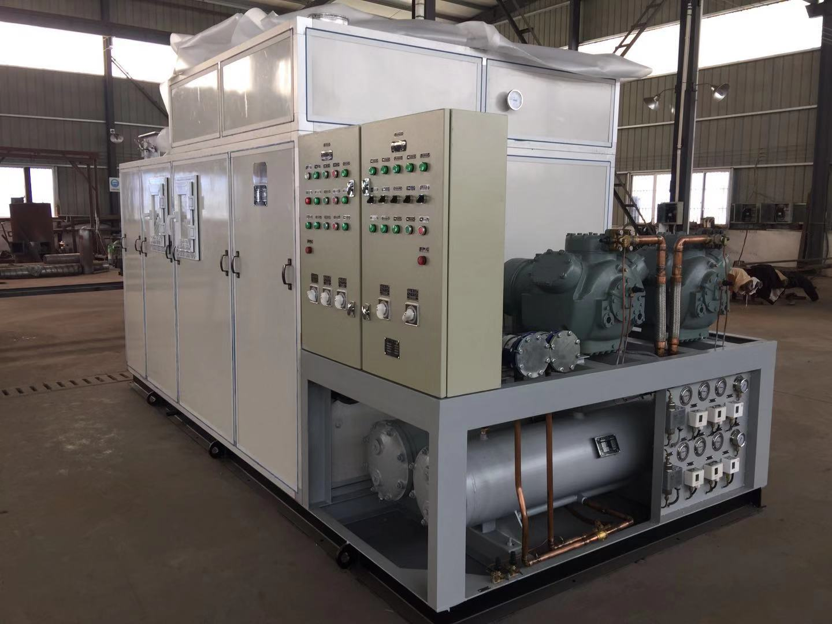


目 录
contents
致用户………………………………………………………3
To Users …………………………………………………3
设备部件说明………………………………………………5
Instructions of the components ……………………5
设备操作说明………………………………………………10
Equipment operation …………………………………10
其他说明事项………………………………………………13
Other matters ……………………………………………13
维护保养……………………………………………………14
Maintenance ………………………………………………14
常见故障排除………………………………………………16
Common troubleshooting ………………………………16
致 用 户
To Users
欢迎你选用本厂制造的CZKR系列船用组装式空调装置。在使用前，请您仔细阅读本使用说明书，以便掌握正确的使用方法，确保设备安全运行及延长使用寿命。
Welcome you to choose our manufacturing CZKR series Marine assembly type air-conditioning equipment. Before using, please read the instructions carefully, to grasp the correct using method, ensure the equipment running safely and longer .
警告！
❒ Cautions!
因用户使用不当造成的设备损坏，不在制造商的保修范围之内。
The improper use of equipment by the users is not in the range of manufacturers warranty
警告!
❒ Cautions!
由于空调设备的电气组件和压力设施有可能导致人身事故，所以切记：专业人员才可安装和维修空调设备。
非专业人员只可做一些维护工作，如清洗过滤网，其它的维修工作要经专业人员完成。
Because of the air conditioning equipment components and electric pressure facilities may cause accidents, so remember: Only professional personnel can do air-conditioning equipment installation and maintenance. Non-professionals can only do some maintenance work, such as clean strainer, other maintenance work to finish by professionals.
警告!
❒ Cautions!
在维护和维修系统时，要切断电源。
使用正确的电压，否则对系统有害。动力线电源用刀闸或空气开关，接线要良好。不要有松动，否则有漏电、触电危险。每隔一个月，需检查并紧固所有电气连接端子。
In maintenance and repairing, remember to cut off power supply.
Using the correct voltage, otherwise it’s harmful to the system. disconnecting link or air switch should be used in power line power supply, and wiring should be good. Do not have loose, or else there is leakage, electric shock risk. Every month, you should check and tighten all the electrical terminals.
警告!
❒ Cautions!
当供电电源的电压不正常时，系统将会出现异常，此时应立即关机，请专业电工人员检查供电系统，直到排除电源故障后，方可重新开机。

When the power supply voltage is abnormal, the system will appear abnormal , at this time , it should be immediately shut down, Please ask the professional electrician personnel to check the power supply system Till the power supply failure be excluded, restart your machine.
警告!
❒ Cautions!
当装置运行出现故障时，应立即关机，并根据此说明书查出故障所在，直到排除故障，方可开机。
When the equipment runs malfunction, it should be immediately shutdown, and find the faults according to the specifications, until the obstacle is conquered , restart your machine.
警告!
❒ Cautions!
冬季或气温很低的地区，需排尽冷凝器中的余水，防止冻坏冷凝器。
Winter or when the temperature is too low, you should drain off the water of the condenser to prevent condenser being frozen.
- 设备部件说明
Instructions of the components 1
13 2

3

12

4

5
6

11
10 9
8 7
出风消音箱
Sound reducing enclosure
制冷压缩机
Cold compressor
根据用户要求选用，可以为全封闭式，半封闭式或开启式，图示为半封闭活塞式制冷压缩机
Depending on the user's requirements, it can be fully enclosed, semi-closed or open, illustrated as a semi-closed piston refrigeration compressor.
干燥过滤器
Device for drying and filtering
仪表板
Dashboard
安装有制冷系统压力监控仪表和控制器，根据用户要求或压缩机的不同，安装位置和元器件不尽相同
With a pressure monitoring instrument and refrigeration system controller, according to the requirements of users or compressor, installation position and components are not all the same
制冷剂供液截止阀
Refrigerant Stop Valves for liquid serving
仅供机组在出厂时集中系统内的制冷剂使用，该操作需由专业人员进行
Only for units in factory on the refrigerant services within the system, the operations are required by professionals
制冷剂充注截止阀
Refrigerant Stop Valves for filling
仅供机组出厂前充注制冷剂使用，机组正常运行时，请确保该截止阀关闭，且末端已用闷头封闭
Only for the unit before filling refrigerants used during normal operation, the unit, please ensure that the globe valve is closed, and ends have been closed by cocks already
冷凝器放水旋塞
Drain cock of the condenser
左右端盖下部各有一个放水旋塞，以便更多的排出冷凝器内余水
Each has a lower left rear water cock, for draining off discharge water in the condenser
船用冷凝器
Marine condenser
冷凝器上端安装有安全阀及放气阀，非专业人与不可随意拆卸或清洗该装置及安装与其上的任何附件
The condenser is installed with relief valve and air evacuation valve, and not random non-professional removal or cleaning the device and installation with any of the attachment
注意：严寒地区或环境温度低于5℃时，用户需自行排尽冷凝器内剩余海水，否则将会损坏冷凝器，且因此原因引起的所有损失，不在制造商保修范围之内
Attention：Cold region or environmental temperature below 5 ° c, the user needs to the condenser water, or within the surplus will damage the condenser, and thus causes any loss, not manufacturers warranty scope
机组电气控制箱
Electric control box of the unit
送风段检修门
Access door for air supply period
空气处理段检修门
Access door for air treatment period
进风端检修门
Access door for air-inlet section
新风及回风调节风阀
Air conditioning wind valve

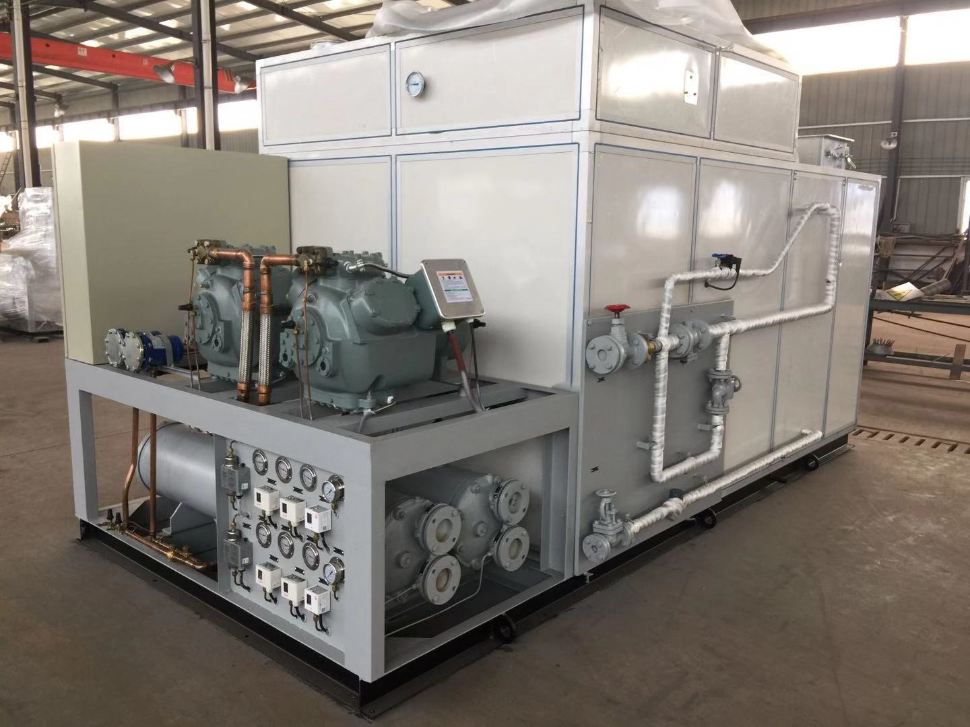
19

18

17

15

14 16
冷却海水进口
Cooling seawater import
冷却海水出口
Cooling seawater outlet
加热蒸汽出口
Heated steam outlet
17加热蒸汽进口
Heating steam import
蒸汽加热根据用户要求选装，并非所有设备均有此接口
Steam heating is installed according to users’ requirements, not all the equipments are being the interface
注意：严寒地区或环境温度低于5℃时，用户需自行排尽蒸汽加热器内剩余凝水，否则将会损坏加热器，且因此原因引起的所有损失，不在制造商保修范围之内
Attention：Cold region or environmental temperature below 5 ° c, the user needs to the steam heaters of water, or within the surplus will damage heater, and thus causes any loss, not manufacturers warranty scope
18出风温度计
Air-out thermometer
19蒸汽加热感温包
Steam heating temperature kits
蒸汽加热根据用户要求选装，并非所有设备均有此接口
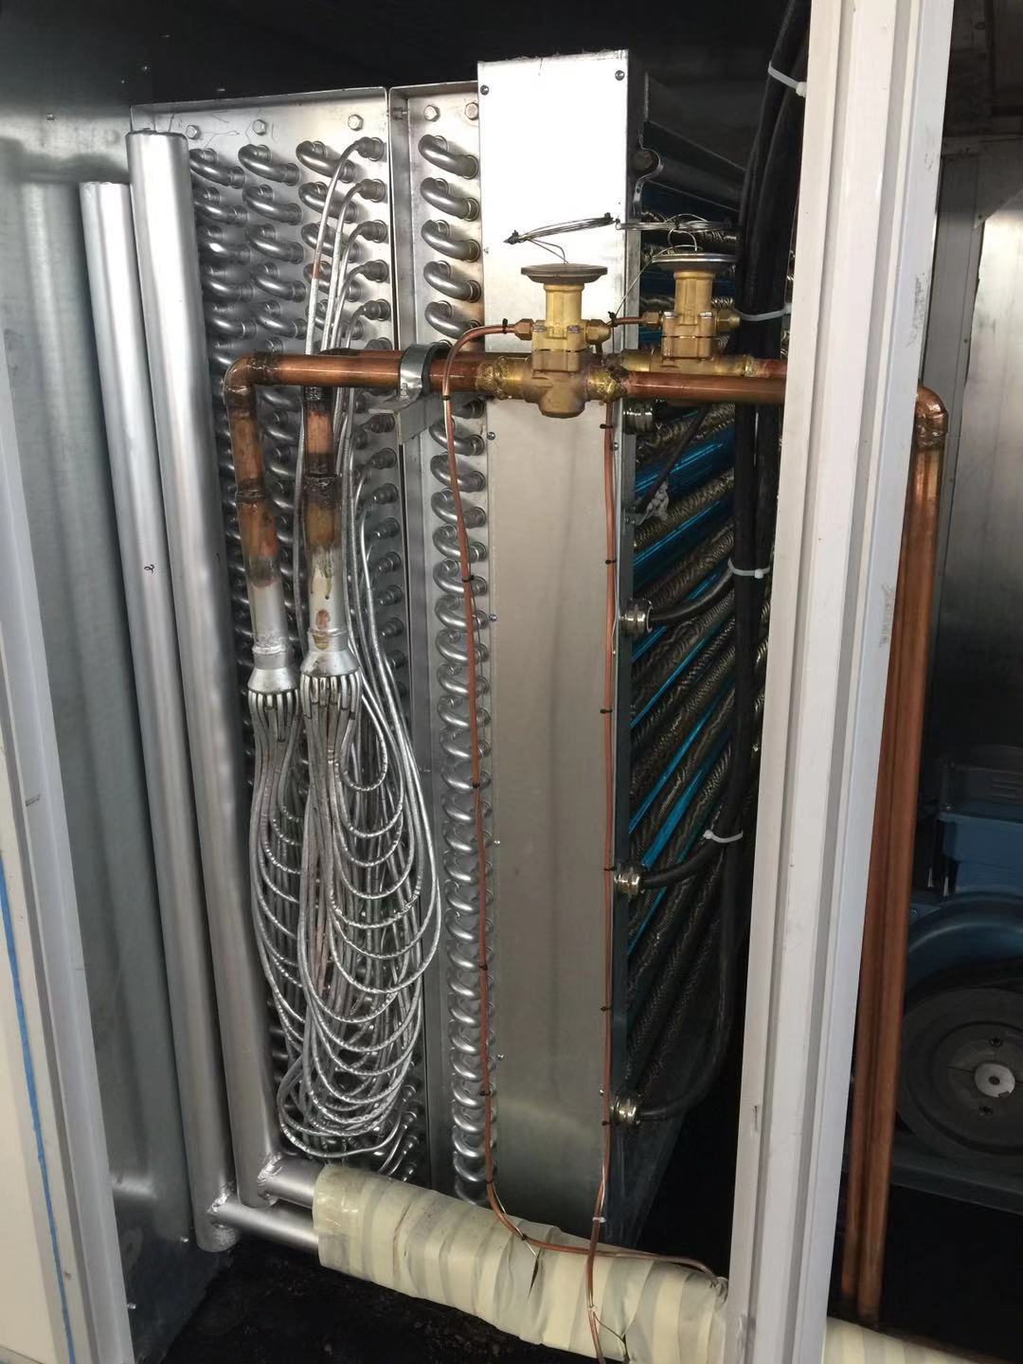
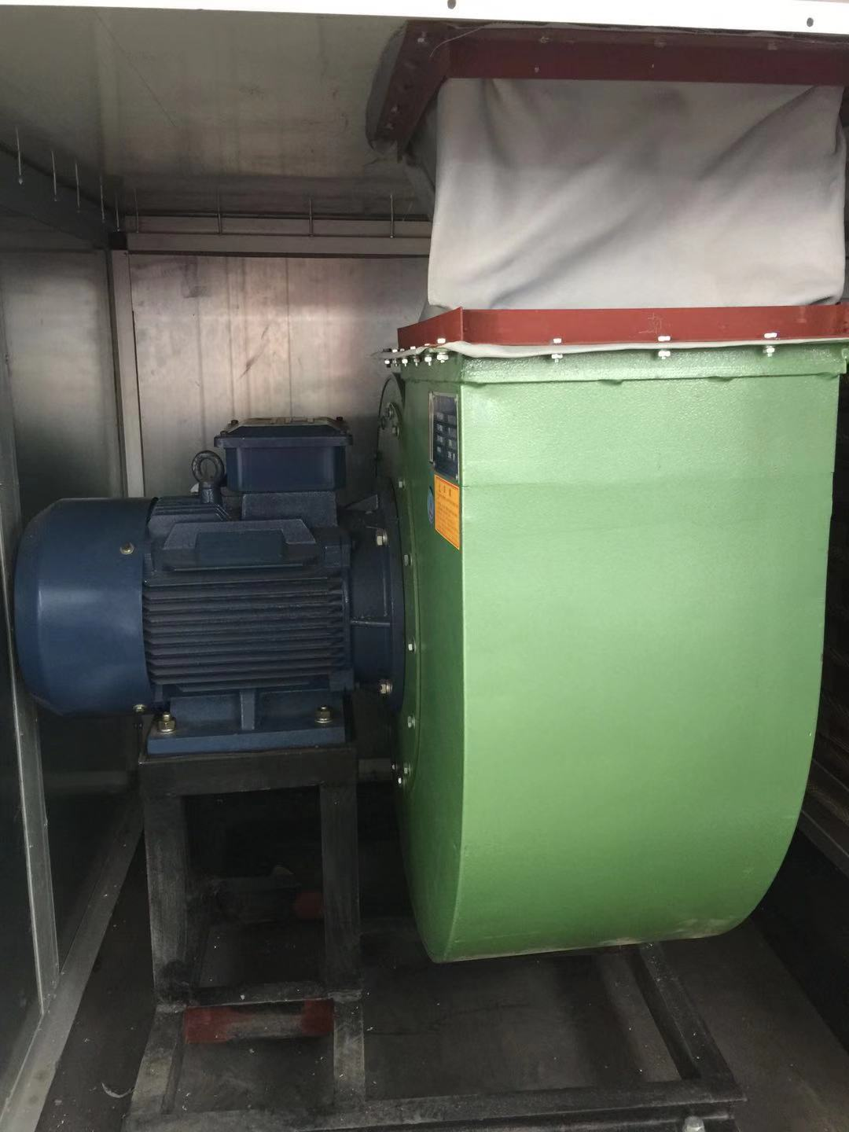
Steam heating is installed according to users' requirements, not all the equipments are being the interface
20
21
22

23

25
24

20蒸发器
Evaporator
21膨胀阀
Expansion valve
22 蒸汽加热器
steam calorifier
23 电加热器
electric heater
24离心风机
Centrifugal fan
25风机电机
Fan motor
- 设备操作说明：
Equipment operation
开机前检查机组压缩机吸（低压）、排（高压）气阀、供液截止阀是否开启；送风管路是否畅通，新回风进风口是否打开；检查机组电源连接是否故障、牢固
Before starting ， inspect the compressor suction (low pressure), row (HVT) valve , the stop valve for liquid is opened, Air pipe expedite, whether to open new return Menorca, Check whether the power connector units fault, firm.
制冷操作
Refrigeration serviceman
1：送合风机及压缩机空气开关，选择机组模式—制冷，曲轴箱加热灯亮，按下风机启动按扭, 风机运行灯亮；
1: Choose the mode of refrigerating units fan and compressor’s air switch, the crankcase heating lamp, press the start button, fan operation indicator will be on;
2：打开冷却水泵，水压表压力在0.07~0.1MPa范围内（低于0.07Mpa水压控制器为保护压缩机触点打开，达到0.1Mpa控制器触点闭合可以下一步操作），水压正常灯亮，确保空调所需的冷却水量后机组可以正常运转;
2: Open the cooling pump, the hydraulic pressure is within the 0.07~0.1MPa range (lower than the 0.07Mpa hydraulic controller to protect the compressor contact open, reaching the 0.1Mpa controller contact closure can be the next operation), the normal water pressure light is on, Ensure that the unit can operate normally after the cooling water required for the air conditioning;
3：把供液电磁阀、能调电磁阀调至自动档，不建议把二者调到手动档位，手动状态下压缩机不受温度控制器保护；
3: Make solenoid valve for liquid and adjustable solenoid valves to automatic transmission, do not recommend them to manual gear, manual condition compressor is not under the temperature controller;
4：最后打开压缩机，把压缩机转换开关调至自动或手动，机组开始制冷运行，压缩机指示灯亮；
4: Finally open the compressor, make the switch to start automatically or manually, when the unit operates, refrigeration compressor indicator will be on
手动启动
Manual Start
按压缩机起动按钮，压缩机运行，指示灯亮；
Press the starting button of the compressor , when the compressor operates indicator will be on；
按压缩机停止按钮，压缩机停止运行；
Press the stop button of the compressor ,the compressor will stop working ；
自动启动
Automatic startup
自动档由低压控制器控制压缩机停止，由温度控制器控制压缩机起动，压缩机运行后，供液阀打开，指示灯亮；由温度控制器控制供液阀的关闭，当供液阀关闭后，压缩机低压停车； 当环境温度高于的设定温度时，压缩机延时（由时间继电器设定），再起动；
Automatic control is controlled by low temperature controller to stop , the temperature controller controls compressor to start , After operation, compressor valve for liquid is open, the indicator will be on , valve for liquid is controlled by the temperature programmer to close, when the valve for liquid is closed , the compressor will be in low-pressure to park, When the environment temperature is higher than the set temperature, compressor delays( set by the time delay), restart；
能调启动
Adjustable starting
压缩机起动为卸载起动，即其起动的7-15S（由时间继电器设定）内能调阀打开，指示灯亮。压缩机具有卸载功能，即当环境温度下降到温度控制器的设定值时，能调阀打开，指示灯亮。当环境温度继续下降到温度控制器的设定值时，能调阀、供液阀关闭，压缩机低压停车。
Compressor starts for unloading, For the start of starting from7 to 15S (set by the time delay) adjustable valve opens, indicator will be on. Compressor has the function of uninstallation, namely when the temperature drops to the temperature controller, adjustable valve can be set to open, indicator will be on. When the environment temperature to drop to the temperature controller, adjustable valve and the valve for liquid will be closed , the compressor will be in low-pressure to park.
5：停车时，先停装置压缩机，再停整个空调系统，一般情况下可不必关闭任何阀门，装置长期停用时应关紧出液阀，将制冷剂全部压入冷凝器内，然后停机，关严压缩机排气阀门；冬季有结冰可能的地区，必须及早放尽冷凝器及整个空调系统内的积水，防止设备冰裂；
5: When parking, stop the compressor device first ,then the air conditioning system , usually there's no need to close any valve, the device should be shut without being used for long-term ，pressure the whole refrigerants to the condenser then stop it, lock the vent valve of the compressor ；Winter ice might area, you must release the water of air conditioning system and the condenser as soon as possible , prevent the water ice cracking equipment.
压缩机具有高（排汽）低（吸汽）压、油压差、过载、超温保护，当其中之一出现故障时，压缩机都不能起动，故障指示灯亮，电铃报警（将万能转换开关切换至零档，可消音），待故障排除后，再将万能转换开关切换至手动档或自动档；
Compressor has high (exhaust) and low(suction) Pressure differential, overload, overheat protection, when one malfunction, compressor can start, fault indicator will be on , alarm bells ring (will shift switches switching to zero, but censored), after the troubleshooting, switch the shift switches to manual or automatic transmission.
采暖操作
Heating operation
开机前检查蒸汽加热管进出口是否打开，蒸汽流动是否畅通，若蒸汽加热器内空气过多，打开蒸汽加热盘管放气阀门，排出空气
Before starting ,inspect if the steam heating tube import and export is open, the steam flow unblocked, if the steam heating the air inside overmuch, open the steam heating coil deflated, let out the exhaust air
1：合上风机及电加热空气开关（电加热属客户选装部件），选择机组运行模式—采暖，按下风机启动按钮，风机运行灯亮；
1:Close fan and electrical heating air switch (electrical heating customers choose option parts), unit operation mode, press the fan heating button, fan operation indicator.
2: 机组根据客户不同的要求分别装配蒸汽（热水、热油）或电加热部件（辅助加热），打开加湿电磁阀或电加热旋钮，加湿电磁阀灯或电加热灯亮，机组进入加热状态；
2:Unit separately according to the different requirements of customers (hot, hot assembly steam electric heating oil) or (assisting heating), open humidifying solenoid valves or electric heating knob, humidifying solenoid valves lamp or electrical heating lamp, units into heating condition.
3: 停车时，先停装置蒸汽或电加热，机组电加热状态停车后切不可立即停止风机，应让风机继续运转3~5分钟，以排除机组内余热防止电加热温度过高灼坏机组内部部件，再停整个空调系统，一般情况下可不必关闭任何阀门，冬季有结冰可能的地区，必须及早放尽蒸汽加热器及整个空调系统内的积水，防止设备冰裂。
3:When parking, first stop device or electrical heating and steam generator electrical heating condition after parking must not immediately stop fan, should let fan continues to run 3 ~ 5 minutes to eliminate waste to prevent electric heating units in high temperature burning internal components, bad units parked the air conditioning system, usually can not close any valve, winter ice might area, must be released as the steam heating and air conditioning system, prevent the water ice crack equipment.

- 其它说明事项
Other matters
- 本厂生产的机组，厂内校验运行时充灌了适量制冷剂，出厂时亦不再抽出，随机附供用户。
（一）Our production units, the factory calibration of the amount of run-time Filling refrigerant, the factory will no longer be drawn randomly attached for the user.
- 机组设计制冷剂以用户指定的制冷剂型号，用户如因特殊原因欲改用其他种类的制冷剂，须更换润滑油。★（此行为非专业人员切不可操作）。本说明书提供的部分参数例如高压、低压、运转电流等将改变，＊不允许将不同种类制冷剂混合使用＊。
（二）The refrigerant of the unit is used according to the users' appointment, if users want to change refrigerant model for special reasons ,we must replace lubricating oil.★（Non-professionals can not do the behavior）。This manual provided for low voltage, some parameters and operating current will change，＊It is not allowed to be mixed use of different kinds of refrigerant＊
- 本厂机组通常用于制取15~20°C空调出风，如用户有特别需要，机组亦可用于低于15°C以下的空调温度。在这种情况下，本说明书所述及的部分条文将不具有指导意义。
（三）Our unit commonly used for making 15 ~ 20 º C air conditioning wind, if users with special needs, the unit can be used in less than 15 ° C air conditioning temperature. In this case, the specification mentioned and some items will not significance.
- 为使机组能正常运行及延长使用寿命，应由专业人员定期对机组进行维护保养。
（四）In order to make the unit can be in normal operation and prolong service life, Only professionals can do regular maintenance.
本厂有权对产品进行技术修改，恕不另行通知。
Our factory has the right to modify product technology without prior notice.

4.维护保养
Maintenance
日常保养和定期保养是装置安全运行的可靠保证，请按下表进行检查和维护保养。
Routine maintenance and regular maintenance are provided with a reliable guarantee for safe operation, please press the table inspection and maintenance.
检查项目  Check each item | 每日  Daily | 每月  Month | 每年  Year | 备 注Notes
压缩机油量  Check compressor oil | √ |  |  | 检查油面镜  oil mirror
运转压力  operation of pressure | √ |  |  | 检查压力表  Check pressure gauge
风机运转声音  Fan running Sound | √
空气滤器（过滤网）Air Filter |  | √ |  | 抽出滤器（过滤网）用中性洗涤液清洗，然后用40℃清水洗净用压缩空气吹干后使用  extracted with neutral detergent solution cleaning filters, and then washed with water before use with compressed air dryer
压缩机排汽阀及其制冷系统中应开启或关闭的阀是否在正确的位置  Compressor exhaust valve and its cooling system should be open or closed valve is in the right place | √
装置接地线完好程度  Device grounding wire intact |  | √
电气线路有无损伤，接线端子有无松动  Availability of electrical wiring damage, whether or loose terminals |  | √
冷凝器表面清洁检查  Condenser surface cleaning inspection |  | √
冷凝器内部清洗  Internal Condenser cleaning |  |  | √ | 打开端盖，用管子刷清洗并检查端盖上防蚀螺塞锌棒腐蚀程度  Open the cover, with the tube cleaning brush and check the drain plug cover on the corrosion of zinc rod corrosio
压缩机油质污染检查  Compressor Oil-pollution inspection |  | √
视液镜干燥程度检查  As the liquid level of inspection mirror dry |  | √
蒸发器表面清洁  Evaporator surface cleaning |  | √
5.常见故障查找和排除
Common troubleshooting
故障现象  Fault phenomena | 可能起因  Possible reasons | 排除方法failure elimination method
压  缩  机  不  工  作  compressor not working | 电源未接通  power supply is not connected | 检查电源、保险丝、电路和开关  check the power supply, fuses, circuit and switch
压  缩  机  不  工  作  compressor not working | 控制电路保险丝烧坏  Control circuit fuse | 检查并更换replace burned-out inspection
压  缩  机  不  工  作  compressor not working | 水泵不运转  Pump does not run | 电源断开—重新启动power off - reboot
压  缩  机  不  工  作  compressor not working | 水泵不运转  Pump does not run | 泵咬紧—松开泵Pump clench - release the pump
压  缩  机  不  工  作  compressor not working | 水泵不运转  Pump does not run | 泵电机烧坏—调换Pump motor burnout - exchange
压  缩  机  不  工  作  compressor not working | 终端连接松动  loose joints | 检查接头Check the terminal connections
压  缩  机  不  工  作  compressor not working | 控制器接线不当  re-wiring improperly | 检查并重新接线  Controller Wiring inspections
压  缩  机  不  工  作  compressor not working | 压缩机电机故障  Compressor motor fault | 检查电机绕组是否开路或短路，绝缘电阻，必要时调换压缩机电机  checking motor windings is open or short circuit, insulation resistance and, if necessary compressor motor swap
压  缩  机  不  工  作  compressor not working | 压缩机卡住  Compressor stuck | 调换压缩机  Compressor swap
压  缩  机  不  工  作  compressor not working | 高低压控制器、油压差控制器、热继电器等保护元件断开  High and low voltage controller,hydraulic differential controller, thermal relays and other protection devices | 查找保护元件断开原因并修理更换  check off the reasons for the protection and repair to replace broken components
压  缩  机  故  障  Compressor fault | 电流过大  Current is too large | 电机绝缘破坏，转动扭矩增大，检查电机绝缘和运动部件配合装配。  motor insulation damage, turning torque increases, check the electrical insulation and moving parts with the assembly
压  缩  机  故  障  Compressor fault | 排气压力过高  Exhaust steam pressure is too high | 冷凝器水量少或污垢过多，加大冷却水量或清洗冷凝器污垢  The condenser water too little or dirt, increase the cooling water or cleaning condenser dirt
压  缩  机  故  障  Compressor fault | 排气压力过高  Exhaust steam pressure is too high | 冷凝器中空气含量高——排出冷凝器中的空气  High levels of air condenser - condenser air discharge
压  缩  机  故  障  Compressor fault | 排气压力过低  Exhaust steam pressure is too low | 出液阀未开足——打开阀门  the valve is not open - open valve stop
压  缩  机  故  障  Compressor fault | 排气压力过低  Exhaust steam pressure is too low | 冷却进水温度过低——减少冷却水量  Condensing capacity too strong - to reduce condensation of water
压  缩  机  故  障  Compressor fault | 排气压力过低  Exhaust steam pressure is too low | 制冷剂不足——查漏并补充制冷剂  Refrigerant shortage - and added refrigerant leak detection
压  缩  机  故  障  Compressor fault | 吸气压力过高  Suction pressure is too high | 热负荷增大——查清负荷后调整  Heat load increase-check adjustment after load
压  缩  机  故  障  Compressor fault | 吸气压力过高  Suction pressure is too high | 压缩机效率降低——检查压缩机  Compressor efficiency reduction-check Compressor
压  缩  机  故  障  Compressor fault | 吸气压力过高  Suction pressure is too high | 膨胀阀开启过大——关小膨胀阀  Expansion valve opening too big-closing small expansion valve
压  缩  机  故  障  Compressor fault | 吸气压力过高  Suction pressure is too high | 油分离器自动回油部件失灵——检查浮球阀及回油状况  Failure of automatic Oil recovery component of Oil Separator: check floating Ball Valve and Oil recovery condition
压  缩  机  故  障  Compressor fault | 吸气压力过低  suction pressure is too low | 制冷剂不足——添加制冷剂  Shortage of refrigerants-addition of refrigerants
压  缩  机  故  障  Compressor fault | 吸气压力过低  suction pressure is too low | 膨胀阀关得太小——微开膨胀阀  Expansion valve closed too small
压  缩  机  故  障  Compressor fault | 吸气压力过低  suction pressure is too low | 低压部分堵塞——查出堵处并修理  Low pressure partial blockage-detect blockages and repair them
压  缩  机  故  障  Compressor fault | 吸气压力过低  suction pressure is too low | 进风量不够——检查空气过滤网是否堵塞，新回风大开不足  Air intake is not enough-check if the air filter is blocked and the new return air is not open enough
压  缩  机  故  障  Compressor fault | 产生不正常响声  Produce an abnormal sound | 阀片断裂——换阀片Breakage of valve vane
压  缩  机  故  障  Compressor fault | 产生不正常响声  Produce an abnormal sound | 运动件装配不良Poor assembly of moving parts
压  缩  机  故  障  Compressor fault | 产生不正常响声  Produce an abnormal sound | 电机定转子相擦——拆检并更换不合格部件  Disassembly, inspection and replacement of unqualified parts of motor with stator and rotor erasure
压  缩  机  故  障  Compressor fault | 产生不正常响声  Produce an abnormal sound | 液击——注意操作防止液击  Liquid strike-pay attention to operation to prevent liquid strike
压  缩  机  故  障  Compressor fault | 油温过高  Exhaust temperature is too high | 压缩机工作压差太大——改变工况  The pressure difference of compressor is too big to change the working condition
压  缩  机  故  障  Compressor fault | 油温过高  Exhaust temperature is too high | 装配间隙过小——拆机修整  The Assembly clearance is too small
压  缩  机  故  障  Compressor fault | 油温过高  Exhaust temperature is too high | 排气温度过高——查明原因  High exhaust temperature-find out the cause
压  缩  机  故  障  Compressor fault | 油温过高  Exhaust temperature is too high | 环境温度过高——加强通风  High ambient temperature-enhancing ventilation
压  缩  机  故  障  Compressor fault | 排气温度过高  controller movements are not normal | 阀片破损——换阀片  Vane breakage-replacement vane
压  缩  机  故  障  Compressor fault | 排气温度过高  controller movements are not normal | 吸入气体过热度大——减少过热度  High superheat of inhaled gases-reduction of superheat
压  缩  机  故  障  Compressor fault | 排气温度过高  controller movements are not normal | 制冷剂偏少——适当补充  Refrigerants on the low side-appropriate replenishment
压  缩  机  故  障  Compressor fault | 排气温度过高  controller movements are not normal | 工作压缩比过大——改变工况  The working compression ratio is too big to change the working condition
压  缩  机  故  障  Compressor failure | 油压过高  Oil pressure is too high | 油压表不正确——更换油压表  The Oil pressure Meter is incorrect-replace the Oil pressure Meter
压  缩  机  故  障  Compressor failure | 油压过高  Oil pressure is too high | 出油管路堵塞——检查清洗  Blockage of Oil outlet Pipelines-Inspection and cleaning
压  缩  机  故  障  Compressor failure | 油压过低  Oil pressure is too low | 油压表不正确——更换油压表  The Oil pressure Meter is incorrect-replace the Oil pressure Meter
压  缩  机  故  障  Compressor failure | 油压过低  Oil pressure is too low | 油泵失灵——调换油泵Oil pump malfunction
压  缩  机  故  障  Compressor failure | 油压过低  Oil pressure is too low | 油管路堵塞——检查清洗  Blockage of tubing-check cleaning
压  缩  机  故  障  Compressor failure | 油压过低  Oil pressure is too low | 油中溶有过多制冷剂——打开油加热器，关小膨胀阀  Too much refrigerant dissolved in oil-turn on the oil heater and close the small expansion valve
压  缩  机  故  障  Compressor failure | 油耗过大  Excessive fuel consumption | 活塞或活塞环磨损过大——调换活塞或活塞环  Piston or ring wear is too large-replace piston or piston ring
压  缩  机  故  障  Compressor failure | 油耗过大  Excessive fuel consumption | 制冷剂液体进入曲轴箱——关小膨胀阀，打开油加热器  Refrigerant liquid enters crankcase-closes small expansion valve, opens oil heater
压  缩  机  故  障  Compressor failure | 油耗过大  Excessive fuel consumption | 油压控制器失灵——调换油压控制器  Failure of Oil pressure Controller
低压控制器接通压缩机关机  Low pressure controller on compressor shutdown | 低压控制器动作不正常  Low voltage controller abnormal operation | 升高压差整定值  Raising pressure difference setting value
低压控制器接通压缩机关机  Low pressure controller on compressor shutdown | 低压控制器动作不正常  Low voltage controller abnormal operation | 检查毛细管是否折皱  Check the capillary for crease
低压控制器接通压缩机关机  Low pressure controller on compressor shutdown | 低压控制器动作不正常  Low voltage controller abnormal operation | 调换控制器Switching controller
低压控制器接通压缩机关机  Low pressure controller on compressor shutdown | 压缩机吸气截止阀部分闭合  Compressor suction stop valve partial closure | 打开阀Open valve
低压控制器接通压缩机关机  Low pressure controller on compressor shutdown | 制冷剂不足  Refrigerant shortage | 加制冷剂Refrigerant
低压控制器接通压缩机关机  Low pressure controller on compressor shutdown | 压缩机吸气滤网堵塞  Compressor suction filter clogging | 洗净滤网Wash filter
高压控制器接通压缩机关机  High pressure controller on compressor shutdown | 高压控制器动作不正常  Abnormal operation of high voltage controller | 检查毛细管是否折皱，根据需要整定控制器  Check capillary wrinkle and set controller as needed
 | 压缩机排气阀部分闭合  Compressor exhaust valve partial closure | 打开阀或如果坏了换新的  Open the valve or replace it if it breaks
 | 系统中有不凝气体  There is no condensing gas in the system | 系统驱气  System gas displacement
 | 冷凝器结垢  Condenser scaling | 清除干净  Clean up
 | 冷凝水泵不工作  The condenser pump doesn't work. | 启动泵，修理或调换  Starting pump, repaired or replaced
机组长时间工作或连续工作  Long hours or continuous work of the unit | 制冷剂量不足  Refrigerant shortage | 加制冷剂  Refrigerant
机组长时间工作或连续工作  Long hours or continuous work of the unit | 控制器夹紧接触点熔断  Controller clamping contact point fuse | 换控制器Exchange controller
机组长时间工作或连续工作  Long hours or continuous work of the unit | 系统中有不凝气体  There is no condensing gas in the system. | 驱气scavenging
机组长时间工作或连续工作  Long hours or continuous work of the unit | 膨胀阀或滤网堵塞  Expansion valve or filter clogging | 清洗或更换Cleaning or replacement
机组长时间工作或连续工作  Long hours or continuous work of the unit | 绝热层失效  Adiabatic failure | 调换或修补To replace or repair.
机组长时间工作或连续工作  Long hours or continuous work of the unit | 冷却负载过大  Excessive cooling load | 门、窗关好Door, window closed.
机组长时间工作或连续工作  Long hours or continuous work of the unit | 压缩机效率不足  Compressor efficiency insufficiency | 检查各阀，必要时作调换  Check the valves and replace them if necessary
系统有噪声System noise | 管道振动  Pipeline vibration | 正确支撑管道，检查管接头是否松开  Properly support the pipe and check that the fittings are loosened
系统有噪声System noise | 膨胀阀有丝声  Expansion valve sound of wire | 加制冷剂Refrigerant
系统有噪声System noise | 膨胀阀有丝声  Expansion valve sound of wire | 检查液体管路滤网是否堵塞  Check to see if the liquid line filter is blocked
系统有噪声System noise | 压缩机有噪声  Compressor noise | 检查阀板是否有噪声  Check the valve plate for noise
系统有噪声System noise | 压缩机有噪声  Compressor noise | 换压缩机（轴承已磨损）  Replacement compressor (bearing worn)
系统有噪声System noise | 压缩机有噪声  Compressor noise | 检查压缩机的螺栓是否松开  Check that the bolts of the compressor are loose
系统有噪声System noise | 风机有不正常响声或振动  Abnormal sound or vibration of the fan | 进风口与叶轮间间隙过小或不均应调整间隙  Small or uneven clearance between Inlet and Impeller should be adjusted
系统有噪声System noise | 风机有不正常响声或振动  Abnormal sound or vibration of the fan | 叶轮动平衡破坏——修整叶轮，重新动平衡  Failure of dynamic balance of impellers Modification and rebalancing of impellers
系统有噪声System noise | 风机有不正常响声或振动  Abnormal sound or vibration of the fan | 电机轴承损坏——更换电机轴承  Damage to motor bearings-replacement of motor bearings
系统有噪声System noise | 风机有不正常响声或振动  Abnormal sound or vibration of the fan | 联接螺栓松动———固紧联接螺栓  Joint bolt loose-fastening joint bolt
系统有噪声System noise | 风机有不正常响声或振动  Abnormal sound or vibration of the fan | 减振器安装不好或损坏——重新安装或更换减振器  The shock absorber is badly installed or damaged-reinstall or replace the shock absorber
吸气管路结霜或出汗  To frost or perspire in the suction line. | 膨胀阀校正不当  Improper correction of expansion valve | 调节膨胀阀variable expansion valve
液体管路发热  Liquid pipe heating | 由于泄漏而缺少制冷剂  Lack of refrigerant due to leakage | 修补并重新填充制冷剂  Repair and refill of refrigerants
液体管路发热  Liquid pipe heating | 膨胀阀校正不当  Improper correction of expansion valve | 调节膨胀阀  variable expansion valve
液体管路结霜  Liquid pipeline frost | 分液器或蒸发器受堵  Liquid separator or evaporator blocked | 打开阀、排堵塞物  Open valve, drain clogging
液体管路结霜  Liquid pipeline frost | 干燥过滤器受堵  Drying filter blocked | 去除堵物或调换滤芯  Removal of blockages or replacement of filter elements
压缩机不卸载  Compressor not unloading | 线圈烧坏Coil burn out | 换线圈Changing coil
压缩机不卸载  Compressor not unloading | 针阀粘住  Needle valve sticking | 清洗wash
压缩机不卸载  Compressor not unloading | 旁通端（低压）堵塞  Bypass end (low pressure) blockage | 清洗  wash
压缩机不卸载  Compressor not unloading | 旁通活塞弹簧疲软  Bypass piston spring weakness | 换新  change for new
压缩机不上载  Compressor not uploaded | 针阀粘住  Needle valve sticking | 清洗  wash
压缩机不上载  Compressor not uploaded | 电磁阀接错线  Solenoid valve misalignment | 纠正或接线Correction or wiring
压缩机不上载  Compressor not uploaded | 旁通端口滤网堵塞(高侧）  Bypass port filter clogging (high side) | 清洗  wash

注意事项：
Note:
- 半封闭压缩机开机前先检查压缩机的排吸阀有没有打开，谨防发生安全事故。
Semi-closed compressor before the start-up check compressor suction valve open, beware of safety accidents.
- 冷凝器和蒸汽加热器不用时，一定将水放干净，防止气温过低铜管冻裂。
When condensers and steam heaters are not used, be sure to clear the water to prevent freezing and cracking of copper tubes with too low temperature.

本操作手册仅适用于泰兴启娴机械系列设备
This manual is only applicable to the Marine air conditioning unit series of Taixing Qixian Marine Machinery Co. Ltd.
本手册最终解释权及修改权归泰兴市启娴船用机械有限公司所有
The manual interpretation and modification to Taixing Qixian Marine Machinery Co.,Ltd.

泰兴市启娴船用机械有限公司
Taixing QiXian Marine Machinery Co. Ltd.

7×24客服热线(Customer service hotline)：（0）13852673821
Web:http://www.txqxjx.com/
Email:taixingqixing@163.com

